Ethephon

HPIC method

CIPAC Small Scale Collaborative Trial

5281/m

ETHEPHON

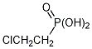

ISO common name Ethephon

Chemical name 2-chloroethylphosphonic acid

CAS No. 16672-87-0

Empirical formula C₂H₆ClO₃P

RMM 144.5

m.p. 74–75 °C

pKa pKa1 2.5, pKa2 7.2

v.p. <0.01 mPa (20 °C)

Solubility In water 800 g/l (pH 4). Readily soluble in methanol, ethanol, isopropanol, acetone, diethyl ether and other polar organic solvents. Sparingly soluble in non-polar organic solvents such as benzene and toluene. Insoluble in kerosene and diesel oil.

Stability Stability Stable in aqueous solutions having pH <5; at higher pH, decomposition occurs with the liberation of ethylene; DT₅₀ 2.4 d (pH 7, 25 °C). Sensitive to uv irradiation

Description White crystalline powder

Formulation Soluble Concentrate (SL)

ETHEPHON technical material
373/TC/M/-

1 Sampling. Take at least 100 g.

2. Identity test

2.1 HPIC. Use the reversed phase HPIC method below. The relative retention time of the ethephon peak in the sample solution should not deviate by more than 1.5% from that of the calibration solution.

2.2 NMR. Use a solution in deuterium oxide containing sodium 3-trimethylsilyl propionate as internal standard. The 1H spectrum of ethephon displays the following characteristics:

a split triplet at δ 2.34 ppm J(H–H) = 7.5 Hz and J(H–C–H) = 18 Hz, corresponding to P-CH2
a split triplet at δ 3.79 ppm J(H–H) = 7.5 Hz and J(H–C–C–H) = 14 Hz, corresponding to CH2Cl.

3 Ethephon

OUTLINE OF METHOD Ethephon is determined by high performance ion chromatography using electrolytic conductivity detector and external standardisation.

REAGENTS

Ethephon reference standard of known content
Water, HPLC grade
Sodium Carbonate, Analytical reagent or Guaranteed Reagent
Sodium Hydroxy Carbonate, Analytical reagent or Guaranteed Reagent

Calibration solution. Prepare calibration solution in duplicate. Weigh (to the nearest 0.1 mg) sufficient reference standard (w mg) to contain about 120 mg of Ethephon into a brown volumetric flask (100 ml). Add ultrapure water to the mark and mix thoroughly. Transfer 5.00 mL of the above solution into a 50 mL volumetric flask, add ultrapure water to the mark and mix thoroughly. (Calibration solutions CA and CB).

APPARATUS

High performance ion chromatograph, equipped with a electrolytic conductivity detector and an injection system capable of injecting 25 µl.
Ion chromatographic column, stainless steel, Dionex IonPac AS23, 250 x 4.0 mm (i.d.), or equivalent with the same selectivity.
Ion chromatographic guard cartridges, stainless steel, Dionex IonPac AG23, 50 x 4.0 mm (i.d.), or equivalent.

Electronic integrator or data system

Analytical Balance

Ultrasonic bath

PROCEDURE

- Liquid Chromatographic conditions (typical)
Mobile phase: 7.2 mM Na₂CO₃ + 9.0 mM NaHCO₃
Flow rate: 1.0 mL/min
Current of inhibitor: 70 mA
Temperature of detector cell: 35℃
Temperature of column: 30℃
Mode of injection: Push Full
Volume of Injection: 25μL
Frequency of data sampling: 5.0 Hz
Run time: 13 min
Retention time: 9.5 min

- Equilibration of the system. Pump sufficient mobile phase through the column to equilibrate the system. Inject 25 µl portion of calibration solution C_{A} until the response obtained from two consecutive injections deviate by less than 1.5%. Then inject 25 µl portion of calibration solution C_{B}. The response factor for this solution should not deviate by more than 1.5% from that for calibration solution C_{A}, otherwise prepare new calibration solutions.

- Preparation of Ethephon TC sample. Prepare sample solutions in duplicate for each sample. Heat the sample in 95 ℃ water bath to melt and mix well. Weigh (to the nearest 0.1 mg) sufficient sample (w mg) to contain about 120 mg of Ethephon into a brown volumetric flask (100 ml). Add ultrapure water to the mark and mix thoroughly. Transfer 5.00 mL of the above solution into a 50 mL volumetric flask, add ultrapure water to the mark and mix thoroughly. (Sample solutions S₁ and S₂).

- Determination. Inject in duplicate 25 μl portions of each sample solution bracketing them by injections of the calibration solutions as follows: calibration solution C_{A}, sample solution S₁, sample solution S₁, calibration solution C_{B}, sample solution S₂, sample solution S₂, calibration solution C_{A}, and so on. Measure the relevant peak areas.

- Calculation. Determine the peak area of Ethephon, calculate the mean value of response factors from the calibration solutions bracketing the injections of the sample solutions, and use this value for calculating the Ethephon content of the bracketed sample. The Ethephon content is the mean value of two sample solutions.

$$f_{i}=\frac{s×P}{H_{s}}$$

Ethephon content $=\frac{f×H_{w}}{w}$ g/kg
where:
f_{i} = individual response factor
f = mean response factor of bracketing calibration injections
H_{s} = peak area of Ethephon in the calibration solution
H_{w} = peak area of Ethephon in the sample solution
s = mass of Ethephon reference standard in the calibration solution (mg)
w = mass of sample taken (mg)
P = purity of Ethephon reference standard (g/kg)

ETHEPHON Technical concentrates

373/TK/M/-

1 Sampling. Take at least 600 ml.

2. Identity test

2.1 HPIC. As for Ethephon technical 373 /TC/M/2.1.

2.2 NMR. As for 373/TC/M/2.2

3 Ethephon

As for Ethephon technical 373/TC/M/3, except that the clause to melt the sample is omitted.

ETHEPHON Soluble concentrates

373/SL/M/-

1 Sampling. Take at least 600 ml.

2. Identity test

2.1 HPIC. As for Ethephon technical 373/TC/M/2.1.

2.2 NMR. As for 373/TC/M/2.2

3 Ethephon

As for Ethephon technical 373/TC/M/3, except that the clause to melt the sample is omitted.

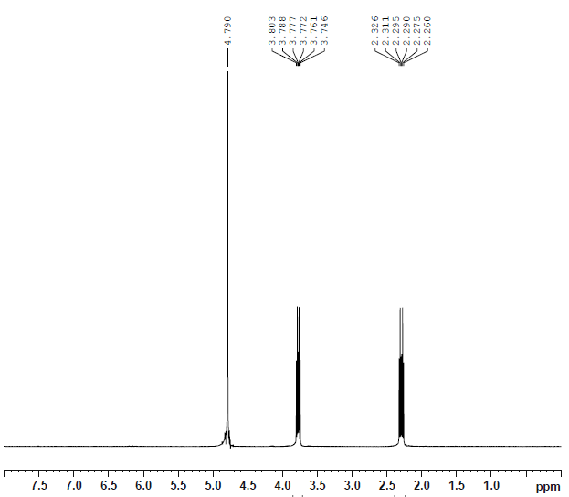
Fig.1 NMR spectrum of Ethephon
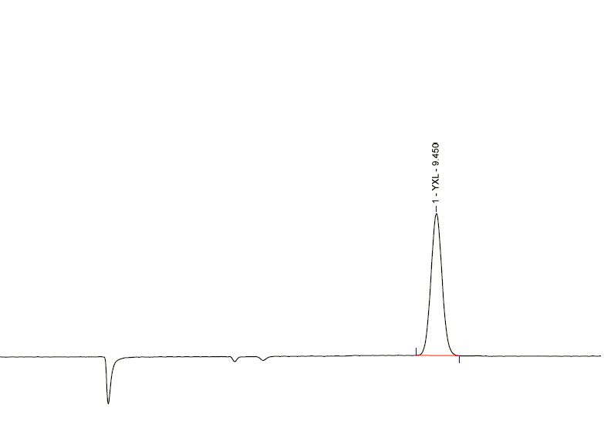

Fig.2 HPIC chromatogram of Ethephon standard

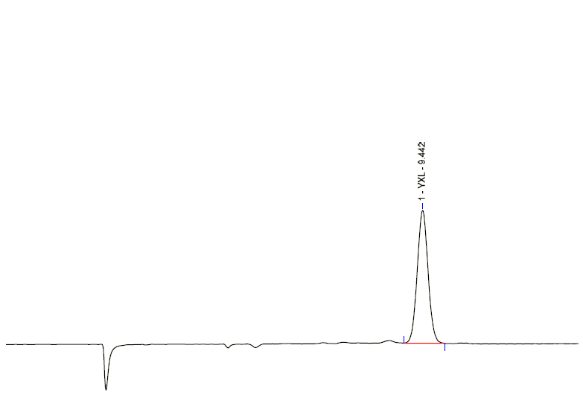
Fig.3 HPIC chromatogram of Ethephon TC

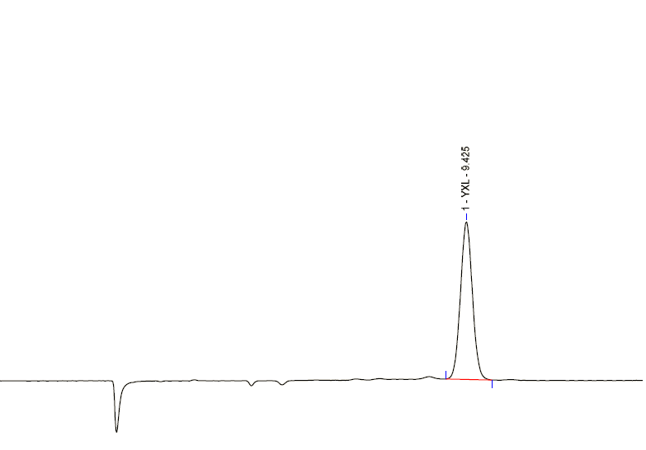
Fig.4 HPIC chromatogram of Ethephon TK

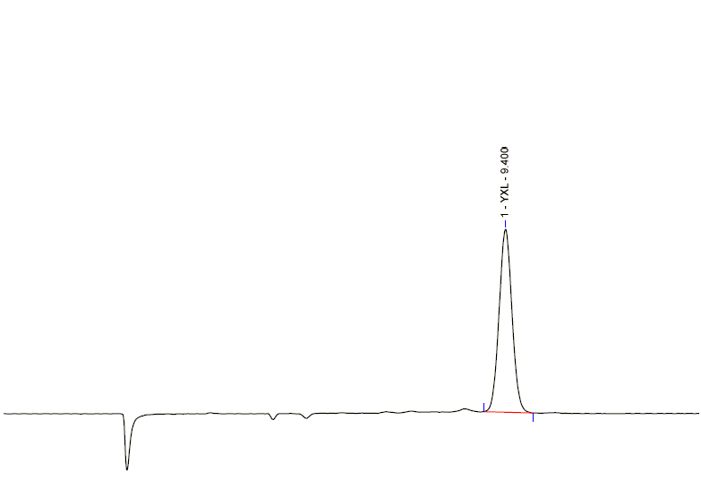
Fig.5 HPIC chromatogram of Ethephon SL

